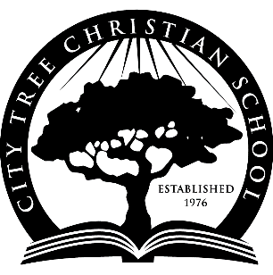
City Tree Christian School
First Presbyterian Church, 320 Date Street, San Diego California619.232.3794 - www.citytree.org - office@citytree.org
Employment Opportunities

City Tree Christian School is a ministry of First Presbyterian Church committed to integrating educational excellence with the teachings of Jesus Christ as found in the Bible. We are an ethnically and socio-economically diverse school located in downtown San Diego. About 155 students attend our school age infant through 8th grade. Our school is a member of Association of Christian Schools International (ACSI) and accredited by the Western Association of Schools and Colleges.

- Preschool Teacher: 2-5 year old teacher, Part-Time
Responsible for assisting in a classroom of 9-12 children mostly ages 2-5 years old, some of whom are working on toilet training. A dependable, mature, and responsible person who is able to integrate their love for Christ with their teaching is desired. Our preschool operates on a year round calendar. Position begins immediately upon hire after training period. Shift will be 1:30pm/2:00pm– 5:30pm/6pm, Monday-Friday.

Qualifications: Teacher must have a minimum of 12 ECE units (2 courses can be in progress.). A Child Development Certificate or Associates Degree or Bachelor’s Degree in Child Development is preferred. Experience with children required. Experience with toilet training and infants through two year olds are preferred. Teacher with “Infant and toddler development” class preferred.
Job Type: Part time afternoon teacher.
Salary: $12.00 to $16.00 /hour depending on education and experience.

Application Process: Download our application from https://www.citytree.org/employment. Complete entire application including Personal Philosophy questions and e-mail to office@citytree.org along with your resume. No candidates will be considered without a completed application and responses to questions.

